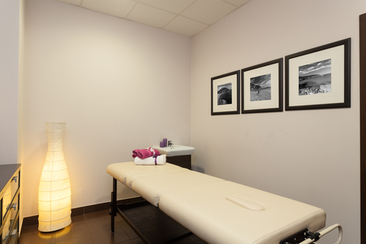

As you develop your tools and strategies for building your practice, return to this meditation. Again and again and again.

Invite your practice to emerge from the Heart’s desire and the 6th Chakras knowing.

Cultivate your practice, affiliate with your clients, commune with your practice space.

A practice that is informed from within thrives.

The following pages can be duplicated to record your meditation experiences as you move through this class and into your practice.
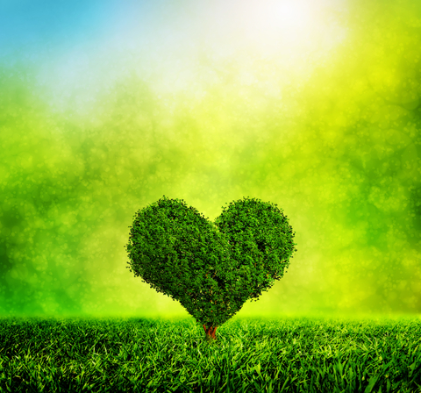 Heart Chakra Meditation

What feelings, images, colors emerge as you contemplate your practice in your Heart Chakra?

What are clients receiving from you?

How does it feel to offer your work to your clients?

Sixth Chakra Meditation

What feelings, images, colors emerge as you contemplate your practice in your 6th Chakra?

What characteristics and qualities emerge as you contemplate your target or ideal clients?

What does it feel like to attract these people to your practice?

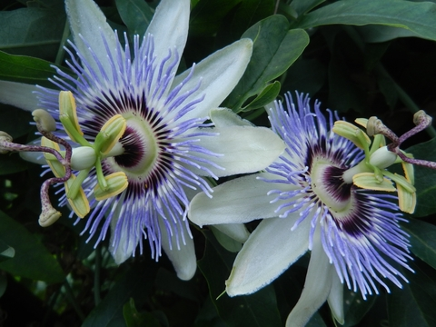 Astral Meditation

What images & feelings emerge as you contemplate your practice in your Astral awareness?

What excites you?

What concerns you?

Place two flowers outside your Aura & move your concerns on to one of the flowers.

Move external concerns (others) onto the second flower. Hand them back. Not mine.

Return awareness to Your flower. Meditate on your concerns and make notes so you can address, resolve, clear those issues.

If your practice was a color, what would it be?
(Review the Color Healing Chart to see if the color resonates with a quality in your practice. Could be used for logo, marketing and other materials.)

Color Healing Chart

Sky blue | knowing intuition, sensitivity, spirituality  [Note: the Embodied Energy System also uses this color – very light blue - for cooling inflammation, and for toning down Kundalini energy that is creating discomfort in the patient/client.]
Royal blue | self-assurance, trust, integrity, around body – physical strength
Cobalt blue | anesthetize
Turquoise blue | humor, folly, play – healing, too
Emerald green | opening of intuitive awareness, psychic awareness
Forest green | prosperity
Apple green | growth, new information, integration time
Red | passion, courage, physical power, physical vitality
Fuchsia | loving, caring, creative inspiration
Pink | love, affinity, humanitarian quality
Citrus orange | creative expression
Burnt orange | body healing, body vitality
Lavender | personal spirituality, self-acceptance
Purple | spiritual seeking, studying
White – flat | etheric quality  [Note: in the Embodied Energy System, this color is used for channeling, and is never run in the body/energy field unless used for conscious channeling.]

White - pearl | integrated sense of spirituality  [Note: in the Embodied Energy System, this color is used for channeling, and is never run in the body/energy field unless used for conscious channeling.]
Lemon yellow | analytical ability
Butter yellow | abstract intuition
Silver | personal power  [Note: in the Embodied Energy System, this color is used for channeling, and is never run in the body/energy field unless used for conscious channeling.]
Gold | harmony, wisdom, psychic protection  [Note: in the Embodied Energy System, this color is used for achieving neutrality, and is the highest vibration/color that can be run in the body/energy field while remaining embodied. There are no limits to the use of this color for clearing, calming, owning space.]
Source: Academy of Intuition Medicine.

